

SEMESTER END REGULAR/SUPPLEMENTARY EXAMINATIONS (AR23), April - 2026

U.G. | CE |  | Degree | Bachelor of Technology
Academic Year | 2025 - 26 |  | Sem. | 4th
Course Code | 23CE403 | Course Title
Course Code | 23CE403 | Solid Mechanics II
Duration | 3 Hours | Maximum Marks |  |  | 70 (SEVENTY)
SECTION-I
7 x 2 = 14 Marks
1.
No. | Questions (a to g) | RBT Level | COs
a | Define principal stresses ad principal planes. | Remember | 1
b | For brittle materials, such as rock and marble, which theory of failure is used and why? | Remember | 1
c | Define the slenderness ratio. | Remember | 3
d | Write the assumptions made in the Euler’s column theory. | Remember | 3
e | Write Lame’s equation for stress in thick cylinder. | Remember | 4
f | Distinguish circumferential stress and longitudinal stress in a cylindrical shell, when subjected to an internal pressure. | Understand | 4
g | List the conditions of stability for retaining walls. | Remember | 6
SECTION-II
4 x 14 = 56 Marks

No. |  | Questions (2 to 9) |  |  | RBT Level | COs | Marks
2 |  | (a) |  | The principal stresses at a point across two perpendicular planes are 75 MN/m²(T) and 35 MN/m². Find the normal, tangential stresses and the resultant stress and its obliquity on a plane at 20⁰ with the axis of major stress. | Apply | 1 | 8M
 |  | (b) |  | The load on a bolt consists of an axial thrust of 8 kN together with a transverse shear load of 4 kN. Calculate the diameter of the bolt using the principal stress theory. Take 3 as FOS. σ _{yp}=285 N/mm², µ = 0.3. | Apply | 2 | 6M
OR
3 |  | (a) |  | An element is subjected to tensile stresses of 60 N/mm² and 20 N/mm² acting on two perpendicular planes and is also accompanied by shear stress of 20 N/mm² on these planes. Determine the magnitudes and directions of principal stresses and also the greatest shear stress. | Apply | 1 | 8M
 |  | (b) |  | Explain about any three theories of failures. | Understand | 2 | 6M
4 |  | (a) |  | Derive the expression for Euler's crippling load when both ends of the column are fixed. | Understand | 3 | 8M
 |  | (b) |  | A hollow shaft of 30 mm internal diameter and 50 mm external diameter is subjected to a twisting moment of 800 Nm and an axial compressive force of 40 kN. Determine the FOS according to: (a) Maximum shear stress theory, (b) Maximum principal strain theory. Given the yield point stress = 280 MPa and µ = 0.3. | Apply | 2 | 6M
OR
5 |  | (a) | Find Euler’s critical load for a hollow cylindrical cast iron column 250 mm external diameter and 25 mm thick, if it is 4 m long and hinged at both the ends. Take E = 8 x 10⁴ N/mm². Compare Euler’s critical load with the Rankine’s critical load taking fc = 550 N/mm² and α = 1/1600. |  | Apply | 3 | 8M
 |  | (b) | A bolt is required to resist an axial tension of 25KN and a transverse shear of 20KN. Find the safe size of the bolt by  - The maximum principal stress theory  - The maximum shear stress theory  The elastic limit of the material is 300 N/mm2. Poisson’s ratio = 0.3 and the factor of safety =3. |  | Apply | 2 | 6M
6 |  | (a) | A cylindrical shell 1 m diameter and 3 m length is subjected to an internal pressure of 2 N/mm². Calculate the minimum thickness, if the stress should not exceed 50 N/mm². Find the change in diameter and volume of the shell. Poisson’s ratio, 1/m = 0.3 and E = 200 kN/mm². |  | Apply | 4 | 8M
 |  | (b) | A cast iron column of a diameter of 250 mm carries a vertical load of 600 kN at a distance of 50 mm from the centre of circular section. Determine the maximum compressive and tensile stresses. |  | Apply | 5 | 6M
OR
7 |  | (a) |  | Calculate the change in diameter ,change in length and change in volume of a thin cylindrical shell 100cm diameter ,1cm thick and 4m long when subjected to internal pressure of 3N/mm² .Take E=2 * 10⁵ N/mm² and poisson’s ratio as 0.3. | Apply | 4 | 8M
 |  | (b) |  | A short column of hollow circular section of internal diameter d and external diameter D is subjected to a vertical load (eccentric). If d = 0.8 D, determine the diameter of the core. | Apply | 5 | 6M
8 |  | (a) |  | A masonry trapezoidal dam 4m high, 1m wide at its top and 3m wide at its bottom retains water on its vertical face. Determine the maximum and minimum stresses at the base: i) When the reservoir is full ii) When the reservoir is empty. Take the weight density of masonry as 19.62 kN/m³ and for water as 9.81 kN/m³. | Apply | 6 | 8M
 |  | (b) |  | A cast iron column of a section of 200 mm × 250 mm is subjected to a vertical load of 300 kN acting at a point 40 mm away (along the diagonal) from the centre. Determine the resulting stress at the corners a, b, c and d of the section.  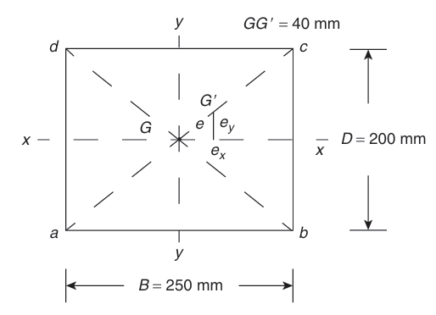 | Apply | 5 | 6M
OR
9 | (a) |  |  | Discuss the stability conditions of dams with neat sketches. | Understand | 6 | 8M
9 | (b) |  |  | In a tension specimen 13 mm in diameter the line of pull is parallel to the axis of the specimen but is displaced from it. Determine the distance of the line of pull from the axis, when the maximum stress is 15 percent greater than the mean stress on a section normal to the axis. | Apply | 5 | 6M

