

SEMESTER END REGULAR/SUPPLEMENTARY EXAMINATIONS (AR23/21), APRIL – 2026
U.G. | CE |  | Degree | Bachelor of Technology
Academic Year | 2025-2026 |  | Sem. | 4th
Course Code | 23CE404/21CE404 | Course Title
Course Code | 23CE404/21CE404 | Structural Analysis
Duration | 3 Hours | Maximum Marks |  |  | 70 (SEVENTY)
SECTION-I
7 x 2 = 14 Marks
1. No. | Questions (a to g) | RBT Level | COs
a | Define strain energy. | Remember | 1
b | State castigliano’s theorem. | Remember | 1
c | List the advantages of continuous beams over fixed beams. | Remember | 3
d | How will you apply Clapeyron’s theorem of three moments to a continuous beam with fixed end supports? | Remember | 3
e | Mention the types of arches based on the number of hinges | Remember | 4
f | Give the applications of two hinged arches | Remember | 4
g | Recall the term sway. | Remember | 6

SECTION-II
4 x 14 = 56 Marks
No. |  | Questions (2 to 9) |  |  | RBT Level | COs | Marks
2 |  | (a) |  | Using Castigliano’s theorem, determine the deflection under single concentrated load applied to a simply supported beam as shown in Figure.1. Take EI as 2.2 MN/m².  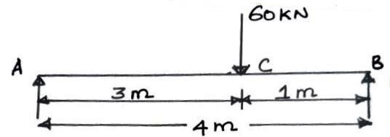  Figure.1 | Apply | 1 | 8M
 |  | (b) |  | A cantilever AB of span 6 m is fixed at the end A and propped at the end B. It carries a point load of 50 kN at the mid span. Level of the prop is the same as that of fixed end. Determine reaction at the prop. | Apply | 2 | 6M
OR
3 |  | (a) |  | A Beam of length 4 m is simply supported at the ends and carries a UDL of 6 kN/m over the entire length. Determine the strain energy stored in the beam. Take E=200 GN/m² and I = 1440 cm⁴. | Apply | 1 | 8M
 |  | (b) |  | A propped cantilever of span 8 m having the prop at the end is subjected to an UDL of 10 kN/m of 3 m span from the left support. Find Prop reaction. | Apply | 2 | 6M
4 |  | (a) |  | A fixed beam AB of length 3 m carries a point load of 45 kN at a distance of 2 m from A. If the flexural rigidity of the beam is 1x10⁴ kNm², Determine  - Fixed end moments at A and B  - Draw SFD and BMD | Apply | 3 | 8M
 |  | (b) |  | Explain the compatibility method for analyzing propped cantilever beams. Why is this method used, and what are the key steps involved? | Understand | 2 | 6M
OR
5 |  | (a) | A continuous beam ABC covers two consecutive span AB and BC of lengths 4 m and 6 m, carrying an UDL of 6 kN/m and 10 kN/m respectively. If the ends A and C are simply supported, find the support moments at A, B and C. Draw shear force diagram and bending moment diagram. |  | Apply | 3 | 8M
 |  | (b) | A propped cantilever beam of length 8m subjected to two point loads 20kN and 40kN at 3m and 6m respectively from left end. Find the final moment at fixed end. |  | Understand | 2 | 6M
6 |  | (a) | A circular (three hinged) arch of span 25 m with a central rise of 5 m is hinged at the crown and the end supports. It carries a point load of 100 kN at 6 m from the left support. Calculate,  - The reaction at the supports and  - Bending moment at 5 m from the left support |  | Apply | 4 | 8M
 |  | (b) | Explain the assumptions made in the slope deflection method. How does this method differ from the moment distribution method? |  | Understand | 5 | 6M
OR
7 |  | (a) |  | A parabolic two hinged arch has a span of 40 m and a rise of 5 m carries concentrated load of 10 kN acts at 15 m from the left support. Calculate the horizontal thrust and reactions at the hinge. | Apply | 4 | 8M
 |  | (b) |  | Discuss how support settlements can be incorporated into the slope deflection equations. Illustrate with a simple beam example. | Understand | 5 | 6M
8 |  | (a) |  | Analyse the continuous beam as shown in figure.4 by moment distribution method.  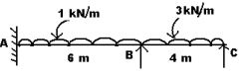  Figure.4 | Apply | 6 | 8M
 |  | (b) |  | Find fixed end moments of the continuous beam ABC as shown in figure 3 by slope deflection method.  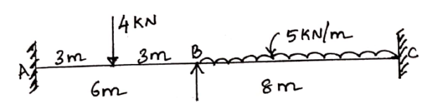  Figure 3 | Apply | 5 | 6M
OR
9 | (a) |  |  | Analyse the frame (figure.5) by moment distribution method.  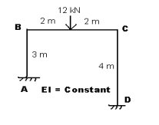  Figure.5 | Apply | 6 | 8M
9 | (b) |  |  | Using slope deflection method, find fixed end moments of the frame shown in figure 4.  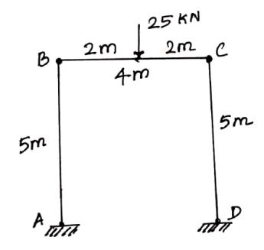  Figure 4 | Apply | 5 | 6M
***********

