

SEMESTER END SUPPLEMENTARY EXAMINATIONS (AR19), April – 2026

U.G. | EEE |  | Degree | Bachelor of Technology
Academic Year | 2025-26 |  | Sem. | 4th
Course Code | 19EE402 | Course Title
Course Code | 19EE402 | Electrical Circuits II
Duration | 3 Hours | Maximum Marks |  |  | 60 (SIXTY)
SECTION-I
6 x 2 = 12 Marks
1.
No. | Questions (a to f) | RBT Level | COs
a | What is meant by time constant? What is its significance? | Understand | 1
b | Write how an Inductor and capacitor behaves at an instantaneous conditions. | Remember | 1
c | Give the properties of Incidence matrix. | Understand | 2
d | How a capacitor with initial voltage is represented in S domain? | Remember | 3
e | Define two-port network | Remember | 4
f | Write the properties of LC driving point immitance functions. | Understand | 5
SECTION-II 6
4 x 12 = 48 Marks

No. |  | Questions (2 to 9) |  | RBT Level | COs | Marks
2 |  | (a) | Derive the expressions for transient current and voltages in RL series circuit excited by DC source. | Understand | 1 | 7M
 |  | (b) | Assuming the switch initially has been open for a long time.  (i)Obtain an expression for i_{w} in the circuit of fig.1 which is valid for all t≥0.  (ii)Calculate i_{w} at t=0 and t=1.3ns.  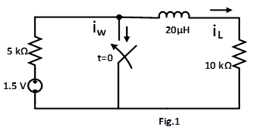 | Apply | 3 | 5M
OR
3 |  | (a) | Derive the expression of transient current flow in RC circuit and obtain the characteristics behavior for unit step excitation under zero initial conditions. | Understand | 1 | 7M
 |  | (b) | For the circuit shown in fig.2, determine the total current delivered by the source when the switch is closed at t=0.  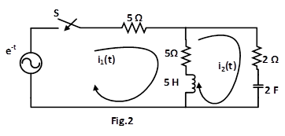 | Apply | 3 | 5M
4 |  | (a) | Find the Y-parameters for the network shown in below fig.3. | Analyze | 4 | 7M
 |  | (b) | Obtain the reciprocity and symmetry conditions for hybrid parameters. | Understand | 4 | 5M
OR
5 |  | (a) | Explain about Series connection and Parallel connection of Two Two-port Networks. | Apply | 4 | 7M
 |  | (b) | Explain the ABCD parameters in terms of Y parameters. |  | 4 | 5M
6 |  | (a) | Explain the procedure for obtaining network functions of Ladder network. | Remember | 5 | 7M
 |  | (b) | Draw the oriented graph of the network shown in Fig.4.Also obtain the Fundamental Cut-set Matrix. | Analyze | 2 | 5M
OR
7 |  | (a) | For the given graph shown in Fig.4, draw the number of possible trees and also write down the basic tie-set matrix for any tree.  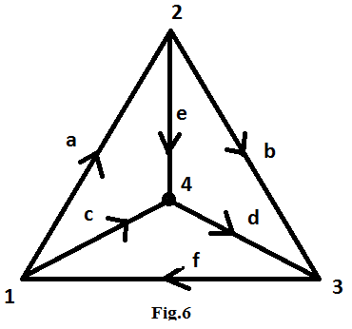 | Analyze | 2 | 7M
 |  | (b) | Draw the dual network for the given network shown in Fig.9.  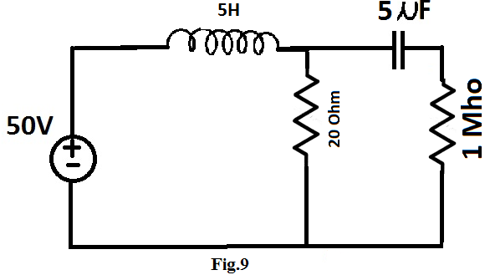 |  | 5 | 5M
8 |  | (a) | Check the positive realness of the following function  $$\frac{s^{2}+2s+4}{(s+3)(s+1)}$$ | Analyze | 6 | 7M
 |  | (b) | Find the second Foster form of RL network for the function.  $$Y\left(s\right)=\frac{s^{2}+8s+15}{s^{2}+5s+4}$$ | Apply | 6 | 5M
OR
9 | (a) |  | Define positive real function and mention its properties. Also write the properties of RL and RC driving point functions. | Understand | 6 | 7M
9 | (b) |  | Find the second Cauer form of the given function.  $$Z\left(s\right)=\frac{(s+1)(s+3)}{s(s+2)}$$ | Apply | 5 | 5M

***********

