

SEMESTER END SUPPLEMENTARY EXAMINATIONS (AR19), APRIL – 2026

U.G. | Mechanical Engineering |  | Degree | Bachelor of Technology
Academic Year | 2025-26 |  | Sem. | VIII
Course Code | 19ME017 | Course Title
Course Code | 19ME017 | FINITE ELEMENT METHODS
Duration | 3 Hours | Maximum Marks |  |  | 60 (SIXTY)
SECTION-I
6 x 2 = 12 Marks
1.
No. | Questions (a to f) | RBT Level | COs
a | What is FEM? State any two advantages of FEM. | Remember | 1
b | State Principle of minimum potential energy. | Remember | 1
c | What is Rayleigh-Ritz method? | Remember | 3
d | Write the Hermite Shape functions for two noded beam element. | Remember | 3
e | Define an isoparametric element and state its importance in FEM. | Understand | 4
f | Write the element stiffness matrix for a one-dimensional heat conduction element. | Remember | 6
SECTION-II
4 x 12 = 48 Marks

No. |  | Questions (2 to 9) |  | RBT Level | COs | Marks
2 |  | (a) | Briefly explain the concept of FEM and also describe the general steps of finite element method. | Understand | 1 | 6M
 |  | (b) | Determine the displacement and stress distribution across the element subjected to a body force ‘f ’ shown in figure using Rayleigh - Ritz method.  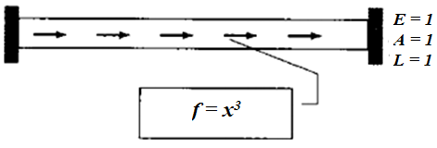 | Apply | 3 | 6M
OR
3 |  |  | A stepped bar is subjected to an axial load of P = 200 kN at the place of change of cross section as shown in figure. Find (i) The nodal displacements (ii) the reaction forces (iii) the induced stresses in each material.  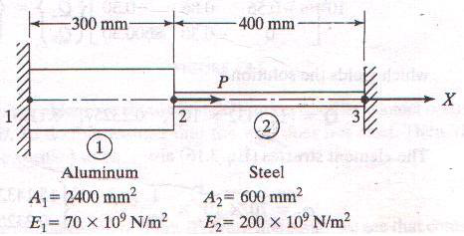 | Apply | 1 | 12M
4 |  |  | Determine the nodal displacements, stresses and reactions for a two-member truss shown in figure.  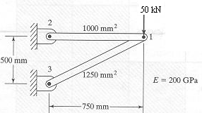 | Apply | 4 | 12M
OR
5 |  | (a) | Briefly explain how the beam element is different from bar and truss elements. | Understand | 4 | 5M
 |  | (b) | A simply supported beam of length 3 m subjected to a point load of 50 kN acting at the centre of the beam. Determine the deflection at the centre of the beam. Take E = 210 GPa and I = 4 x 10⁶ mm⁴. | Apply | 4 | 7M
6 |  |  | Determine the nodal displacements and stresses for triangular element loaded as shown in figure. | Apply | 5 | 12M
OR
7 |  | (a) | An isoparametric four noded quadrilateral element shown in figure, determine the cartesian co-ordinates of point P which has natural co-ordinates ε = 0.5 and η = 0.5.  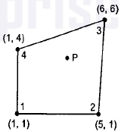 | Apply | 5 | 6M
 |  | (b) | Evaluate the integral $I=\int_{-1}^{+1}{\left[3e^{x}+x^{2}+\frac{1}{(x+2)}\right]dx}$ using one point and two point Gaussian quadrature. Compare with exact solution. Use the following Gaussian Quadrature data. | Apply | 5 | 6M
  Number of Points (n) | Point(s) xᵢ | Weight(s) wᵢ
  1-Point | x₁ = 0.0 | w₁ = 2.0
  2-Point | x₁ = -1/√3 ≈ -0.57735  x₂ = +1/√3 ≈ +0.57735 | w₁ = 1.0  w₂ = 1.0
8 |  |  | A uniform aluminium circular fin of diameter 0.8 cm and 6 cm length is extruded from the surface whose temperature is 100°C. The convection takes place from the lateral surface and tip of the fin. Assuming k = 20 W/mK, h = 100 W/m²K and T∞ = 20°C, determine the temperature distribution in the fin using three element model. | Apply | 6 | 12M
OR
9 |  |  | Determine the Eigen values and Eigen vectors for the stepped bar shown in figure. Take ρ = 7830 kg/m³ and E = 2.1 x 10¹¹ N/m².  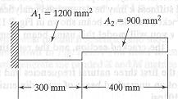 | Apply | 2 | 12M

***********

