

SEMESTER END REGULAR EXAMINATIONS (AR23) DEC. – 2025
U.G. | Common to all (C, D & E sections) |  | Degree | Bachelor of Technology
Academic Year | 2025-26 |  | Sem. | 1st
Course Code | 23BEX04 | Course Title
Course Code | 23BEX04 | ENGINEERING GRAPHICS
Duration | 90 Min. | Maximum Marks |  |  | 35 (Thirty Five)

SECTION-I
Conventional Drawing

No. | Questions | COs | Marks
1 | The focus of a hyperbola is 65 mm from its directrix. Draw the curve if the eccentricity is 3/2· Draw a normal and a tangent at a point on the curve, 75 mm from the directrix. | 1 | 7M
OR
2 | Construct an ellipse when the foci of an ellipse are 90 mm apart and the minor axis is 65 mm long. | 1 | 7M
3 | A line AB, 90 mm long, is inclined at 45° to the H.P. and its top view makes an angle of 60° with the V.P. The end A is in the H.P. and 12 mm in front of the V.P. Draw its front view and find its true inclination with the V.P. | 2 | 14M
OR
4 | Draw the projections of a regular pentagonal plane of 25mm side with its surface making an angle of 45⁰ with HP. One of the sides of the pentagon is perpendicular to VP. | 2 | 14M
5 | Draw the projections of a pentagonal pyramid with a base edge of 30 mm and axis 50 mm long, having its base on the H.P. and an edge of the base parallel to the V.P. | 3 | 14M
OR
6 | A hexagonal prism of side of base 2.5 cm long and axis 5 cm long, has one of its rectangular faces parallel to the H.P. Its axis is perpendicular to the V.P. and 3.5 cm above the ground. Draw its projections when the nearer end is 2 cm in front of the V.P. | 3 | 14M

***********

SEMESTER END REGULAR EXAMINATIONS (AR23) DEC. – 2025
U.G. | Common to all (C, D & E sections) |  | Degree | Bachelor of Technology
Academic Year | 2025-26 |  | Sem. | 1st
Course Code | 23BEX04 | Course Title
Course Code | 23BEX04 | ENGINEERING GRAPHICS
Duration | 90 Min. | Maximum Marks |  |  | 35 (Thirty Five)

SECTION-II
Auto CAD Drawing

No. | Questions | COs | Marks
7 | A hexagonal pyramid, base 25 mm side and axis 50 mm long, has an edge of its base on the ground. Its axis is inclined at 30° to the ground and parallel to the V.P. Draw its projections. | 4 | 7M
OR
8 | A square prism, base 40 mm side, axis 80 mm long, has its base on the H.P. and its faces equally inclined to the V.P. It is cut by a plane, perpendicular to the V.P., inclined at 60° to the H.P. and passing through a point on the axis, 55 mm above the H.P. Draw its front view, sectional top view and true shape of the section. | 4 | 7M
9 | A hexagonal pyramid with side of base 30 mm and height 75 mm stands with its base on H.P. and an edge of the base parallel to V.P. It is cut by a plane perpendicular to V.P., inclined at 45° to H.P. and passing through the mid-point of the axis. Draw the develop the lateral surface of the truncated pyramid. | 5 | 14M
OR
10 | A cone, 50 mm base diameter and 70 mm axis is standing on it’s base on H.P. It cut by a section plane 45° inclined to H.P. through base end of end generator. Draw the development of surfaces of remaining solid. | 5 | 14M
11 | 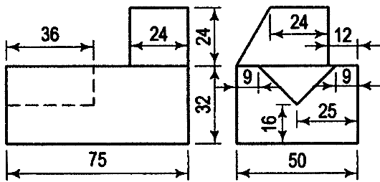  Draw the isometric view of casting, whose orthographic views are given in figures. All dimensions are in mm. | 6 | 14M
OR
12 | 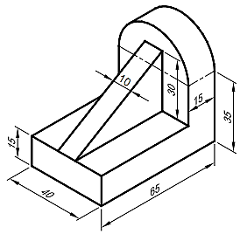  Isometric view of an object is shown in figure. Draw the front view, top view and the left side view. All dimensions are given in mm. | 6 | 14M
***********

