

SEMESTER END REGULAR/SUPPLEMENTARY EXAMINATIONS (AR23), DEC. – 2025

U.G. | Common to all (H & I sections) |  | Degree | Bachelor of Technology
Academic Year | 2025-26 |  | Sem. | 1st
Course Code | 23BEX04 | Course Title
Course Code | 23BEX04 | ENGINEERING GRAPHICS
Duration | 90 Min. | Maximum Marks |  |  | 35 (Thirty Five)

SECTION-I
Conventional Drawing

No. | Questions | COs | Marks
1 | Construct an ellipse when the distance of the focus from the directrix is equal to 80 mm and eccentricity is 3/5 | 1 | 7M
OR
2 | Construct a scale of 1 : 32 to read meters and decimeters, and long enough to measure 4 m. Show on this scale a distance of 2.4 m | 1 | 7M
3 | A line PQ, 65 mm long, has its end P 20 mm above the HP and 25 mm in front of the VP. The end Q is 40 mm above the HP and 65 mm in front of the VP. Draw the projections of AB and show its inclinations with the HP and the VP. | 2 | 14M
OR
4 | Draw the projections of a regular pentagonal plane of 25mm side with is surface making an angle of 45⁰ with HP. One of the sides of the pentagon is parallel to HP and 15mm away from it. | 2 | 14M
5 | A square Pyramid base 40 mm side and axis 75 mm long resting on its base on the HP. Draw its projections when (a) A side of the base is parallel to the VP, (b) A side of the base is inclined at 30⁰ to the VP, (c) All sides of the base are equally inclined to the VP. | 3 | 14M
OR
6 | A regular hexagonal prism of base edge 30 mm and axis 60 mm rests on an edge of its base in the HP. Its axis is parallel to VP and inclined at 45⁰ to the HP. Draw its projections. | 3 | 14M

***********

SEMESTER END REGULAR/SUPPLEMENTARY EXAMINATIONS (AR23), DEC. – 2025
U.G. | Common to all (H & I sections) |  | Degree | Bachelor of Technology
Academic Year | 2025-26 |  | Sem. | 1st
Course Code | 23BEX04 | Course Title
Course Code | 23BEX04 | ENGINEERING GRAPHICS
Duration | 90 Min. | Maximum Marks |  |  | 35 (Thirty Five)
SECTION-II
Auto CAD Drawing
No. | Questions | COs | Marks
7 | A hexagonal pyramid, base 30 mm side and axis 60mm long, has an edge of its base on the ground. Its axis is inclined at 30⁰ to the HP and parallel to the VP. Draw its projections. | 4 | 7M
OR
8 | A square pyramid of base side 40 mm and axis 60 mm is resting on its base on the H.P. with a side of base parallel to the V.P. Draw its sectional front and top views, if it is cut by a section plane perpendicular to the V.P., parallel to the H.P. and bisecting the axis. | 4 | 7M
9 | A square prism of base side 40 mm and axis 70 mm is resting on its base on the HP with a rectangular face parallel to the VP. Draw the development of prism. | 5 | 14M
OR
10 | A hexagonal pyramid with side of base 30 mm and height 75 mm stands with its base on H.P. and an edge of the base parallel to V.P. It is cut by a plane perpendicular to V.P., inclined at 45° to H.P. and passing through the mid-point of the axis. Draw the develop the lateral surface of the truncated pyramid. | 5 | 14M
11 | 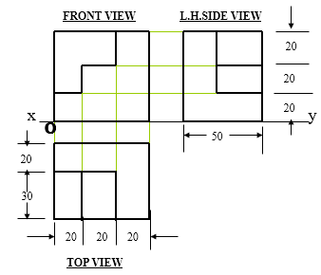  Draw the Isometric view of the following orthographic views shown in Fig.1 and show the Dimensions.  Fig. 1 | 6 | 14M
OR
12 | 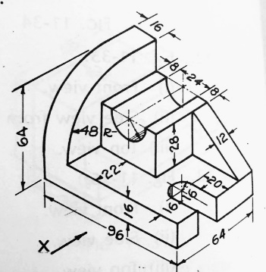  Draw orthographic views (Front View, Top View and Side views) of the following orthographic views shown in Fig.2. Show the dimensions.  Fig. 2 | 6 | 14M
***********

