

SEMESTER END REGULAR/SUPPLEMENTARY EXAMINATIONS (AR23), Dec. – 2025

U.G. | Common to all (F & G sections) |  | Degree | Bachelor of Technology
Academic Year | 2025-26 |  | Sem. | 1st
Course Code | 23BEX04 | Course Title
Course Code | 23BEX04 | ENGINEERING GRAPHICS
Duration | 90 Min. | Maximum Marks |  |  | 35 (Thirty Five)

SECTION-I
Conventional Drawing

No. | Questions | COs | Marks
1 | The major axis of an ellipse is 150 mm long and the minor axis is 100 mm long. Find the foci and draw the ellipse by 'arcs of circles' method. Draw a tangent to the ellipse at a point on it 25 mm above the major axis. | 1 | 7M
OR
2 | A ball thrown up in the air reaches a maximum height of 45 m and travels a horizontal distance of 75 m. Trace the path of the ball, assuming it to be parabolic using tangent method. | 1 | 7M
3 | The top view of a 75 mm long line AB measures 65 mm, while the length of its front view is 50 mm. It’s one end A is in the H.P. and 12 mm in front of the V.P. Draw the projections of AB and determine its inclinations with the H.P. and the V.P. | 2 | 14M
OR
4 | Draw the projections of a regular hexagon of 25 mm side, having one of its sides in the H.P. and inclined at 60° to the V.P., and its surface making an angle of 45° with the H.P. | 2 | 14M
5 | A pentagonal prism having a base with 30 mm side and 60 mm long axis, has one of its bases in the V.P. Draw its projections when a rectangular face perpendicular to H.P. | 3 | 14M
OR
6 | Draw the projections of a square pyramid of base 30 mm side and axis 75 mm long having one of its triangular faces in the V.P. and the axis parallel to and 40 mm above the H.P. | 3 | 14M

***********

SEMESTER END REGULAR/SUPPLEMENTARY EXAMINATIONS (AR23), Dec. – 2025
U.G. | Common to all (F & G sections) |  | Degree | Bachelor of Technology
Academic Year | 2025-26 |  | Sem. | 1st
Course Code | 23BEX04 | Course Title
Course Code | 23BEX04 | ENGINEERING GRAPHICS
Duration | 90 Min. | Maximum Marks |  |  | 35 (Thirty Five)

SECTION-II
Auto CAD Drawing

No. | Questions | COs | Marks
7 | Draw the projections of a cone, base 75 mm diameter and axis 100 mm long, lying on the H.P. on one of its generators with the axis parallel to the V.P. | 4 | 7M
OR
8 | A cylinder of 40 mm diameter, 60 mm height and having its axis vertical, is cut by a section plane, perpendicular to the V.P., inclined at 45° to the H.P. and intersecting the axis 32 mm above the base. Draw its front view, sectional top view and true shape of the section. | 4 | 7M
9 | Draw the development of the lateral surface of a square pyramid, side of base 30 mm and height 50 mm, resting with its base on H.P. and an edge of the base parallel to V.P. | 5 | 14M
OR
10 | A pentagonal prism side of base 30 mm and axis 50 mm long is standing on H.P. on its base with one side of the base perpendicular to V.P. It is cut by a section plane inclined at 45^{O} to the H.P., through mid-point of axis. Draw the development of surface of remaining solid. | 5 | 14M
11 | Draw the isometric view of casting, whose orthographic views are given in figures. All dimensions are in mm.  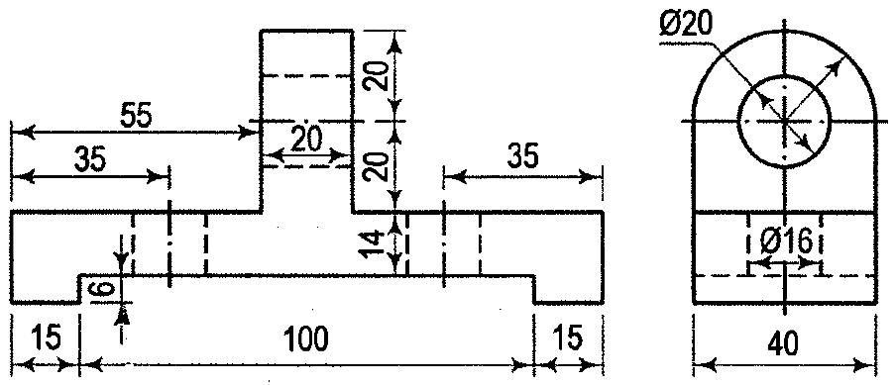 | 6 | 14M
OR
12 | Isometric view of an object is shown in figure. Draw the front view, top view and the left side view. All dimensions are given in mm.  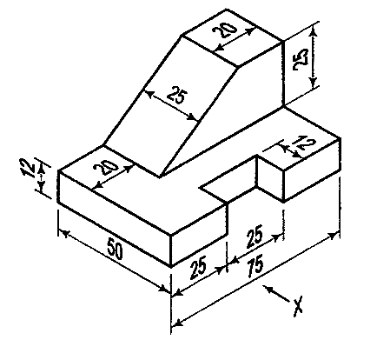 | 6 | 14M
***********

