

SEMESTER END SUPPLEMENTARY EXAMINATIONS (AR16), DEC. - 2025
U.G. | Common to All |  | Degree | Bachelor of Technology
Academic Year | 2025-26 |  | Sem. | 1st
Course Code | 16MEX01 | Course Title
Course Code | 16MEX01 | Engineering Mechanics
Duration | 3 Hours | Maximum Marks |  |  | 60 (SIXTY)

SECTION-I
6 x 2 = 12 Marks
1.
No. | Questions (a to f) | RBT Level | COs
a | Define moment and couple. | Remember | 1
b | What is Lami’s theorem | Remember | 1
c | What is the difference between centroid and centre of gravity? | Remember | 2
d | Define angle of friction and cone of friction. | Remember | 4
e | State and explain the law of conservation of energy. | Remember | 4
f | What is deficient frame and redundant frame? | Remember | 6
SECTION-II
4 x 12 = 48 Marks
No. |  | Questions (2 to 9) |  | RBT Level | COs | Marks
2 |  | Explain System of forces with nest sketches |  | Understand | 1 | 12M
OR
3 |  | A ball of weight 120 N rests in a right-angled groove, as shown in Fig. The sides of the groove are inclined to an angle of 30° and 60° to the horizontal. If all the surfaces are smooth, then determine the reactions RA and RC at the points of contact.  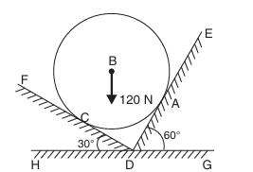 |  | Apply | 1 | 12M
4 |  | Locate the centroid for the I-section shown in Fig.  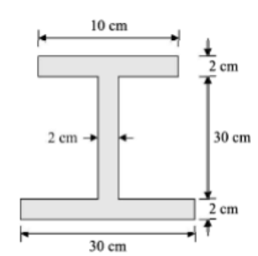 |  | Apply | 2 | 12M
OR
5 |  | Find the moment of inertia of a semi-circle about its centroidal axes |  | Understand | 3 | 12M
6 |  | A belt is running over a pulley of diameter 120 cm at 200 r.p.m. The angle of contact is 165° and co-efficient of friction between the belt and pulley is 0.3. If the maximum tension in the belt is 3000 N, find the power transmitted by the belt |  | Apply | 5 | 12M
OR
7 |  | A body of weight 500 N is pulled up an inclined plane, by a force of 350N. The inclination of the plane is 30° to the horizontal and the force is applied parallel to the plane. Determine the co-efficient of friction. |  | Apply | 4 | 12M
8 |  | Determine the forces in all the members of the structure shown in figure  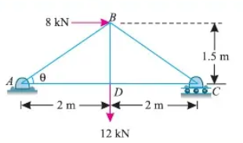 |  | Apply | 6 | 12M
OR
9 | (a) |  | Differentiate between a perfect frame and imperfect frame | Understand | 4 | 6M
9 | (b) |  | State the principle of virtual work and explain how it can be used for solving problems in statics. | Understand | 4 | 6M

***********

