

SEMESTER END REGULAR/SUPPLEMENTARY EXAMINATIONS (AR23), JUNE – 2026
U.G. | ECE |  | Degree | Bachelor of Technology
Academic Year | 2025-2026 |  | Sem. | 2nd Semester
Course Code | 23EC201 | Course Title
Course Code | 23EC201 | Network Analysis
Duration | 3 Hours | Maximum Marks |  |  | 70 (SEVENTY)
SECTION-I
7 x 2 = 14 Marks
1.
No. | Questions (a to g) | RBT Level | COs
a | Write the formulas for delta connected network for a equivalent star connected network. | Remember | 1
b | State Millman’s theorem. | Remember | 1
c | Write the formulae for Active and Reactive powers in an electrical circuit | Remember | 3
d | Define bandwidth, quality factor of parallel resonance circuit. | Remember | 3
e | Write the relation between z- and Y-parameters? | Remember | 4
f | Write the expression for Laplace transform. | Remember | 4
g | Define transient. | Remember | 6
SECTION-II
4 x 14 = 56 Marks

No. |  | Questions (2 to 9) |  | RBT Level | COs | Marks
2 |  | (a) | State and Explain KVL with an example. | Understand | 1 | 8M
 |  | (b) | Find current passing through 3Ω resistor by Using Superposition theorem.  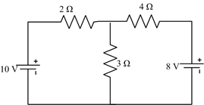 | Apply | 2 | 6M
OR
3 |  | (a) | Find all the node voltages and current flowing through 6Ω resistor for the circuit shown in Figure using nodal analysis.  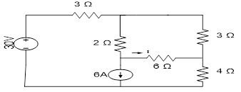 | Understand | 1 | 8M
 |  | (b) | Obtain the Thevenins equivalent resistance R_{th} and Voltage V_{th} across a-b terminals for the circuit shown in Figure.  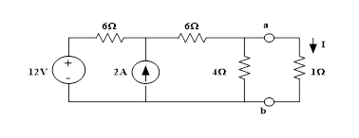 | Apply | 2 | 6M
4 |  | (a) | Explain series RC circuit with phasor notation. | Understand | 3 | 8M
 |  | (b) | Explain Maximum power transfer theorem with example. | Understand | 2 | 6M
OR
5 |  | (a) | Determine the current drawn by the series parallel circuit shown in below Figure.  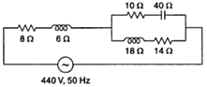 | Understand | 3 | 8M
 |  | (b) | Explain Reciprocity theorem with example. | Understand | 2 | 6M
6 |  | (a) | Develop an expression for equivalent inductance of two coils connected in parallel aiding. | Understand | 4 | 8M
 |  | (b) | Evaluate Y-parameters of the network shown below.  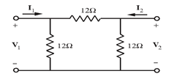 | Understand | 5 | 6M
OR
7 |  | (a) | Explain the concept of Dot convention for series aiding and series opposing with examples. | Understand | 4 | 8M
 |  | (b) | Interpret the relationship between Admittance (Y) and ABCD parameters. | Understand | 5 | 6M
8 |  | (a) | Derive the expression for instantaneous current in a series RC circuit for t>0, when a unit step voltage source is applied at t=0. | Understand | 6 | 8M
 |  | (b) | Derive h-Parameters for two-port network. | Understand | 5 | 6M
OR
9 | (a) |  | Use the Laplace Transforms method to find the current in a series RL circuit. | Understand | 6 | 8M
9 | (b) |  | Derive ABCD-Parameters for two-port network. | Understand | 5 | 6M

***********

