
SEMESTER END REGULAR/ SUPPLEMENTARY EXAMINATIONS (AR23), June – 2026
U.G. | MECH & CE |  | Degree | Bachelor of Technology
Academic Year | 2025-2026 |  | Sem. | 2nd
Course Code | 23ME201 | Course Title
Course Code | 23ME201 | Engineering Mechanics
Duration | 3 Hours | Maximum Marks |  |  | 70 (SEVENTY)
SECTION-I
7 x 2 = 14 Marks
No.1 | Questions (a to g) | RBT Level | COs
a | Define resultant force. | Remember | 1
b | State Lami’s theorem. | Remember | 1
c | Define centroid. | Remember | 3
d | State parallel axis theorem. | Remember | 3
e | List any two practical examples of a truss. | Remember | 4
f | List any four assumptions taken while analysing the forces in trusses. | Remember | 4
g | State impulse momentum principle. | Remember | 6
SECTION-II
4 x 14 = 56 Marks
No. |  | Questions (2 to 9) |  | RBT Level | COs | Marks
2 |  | (a) | A system of four forces acting on a body are shown in Fig. Determine the magnitude and direction of resultant force.  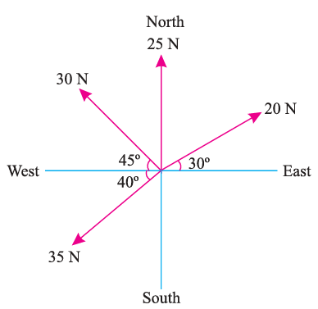 | Apply | 1 | 8M
 |  | (b) | A block of weight 150 N is sliding on a horizontal surface. The coefficient of kinetic friction between the block and the surface is 0.3. Calculate the frictional force acting on the block. Draw the free body diagram. | Apply | 2 | 6M
OR
3 |  | (a) | Classify different types of force systems and explain each of them. | Understand | 1 | 8M
 |  | (b) | What is the value of P in the system shown in fig. to cause the motion of 500 N block to the right side? Assume the pulley is smooth and the coefficient of friction between other contact surfaces is 0.2.  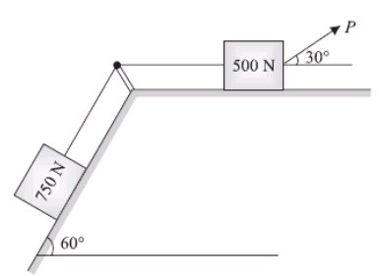 | Apply | 2 | 6M
4 |  | (a) | Fig. shows a truss consisting of seven members each of 3 m length freely supported at its end points. The girder is loaded at B and C as shown. Find the reactive forces at A and D and the forces in all members of the girder, indicating whether the force is compressive or tensile.  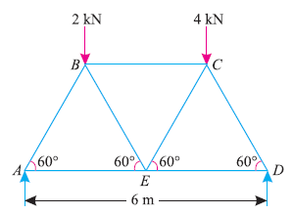 | Apply | 3 | 8M
 |  | (b) | Write about laws of dry friction, angle of friction, coefficient of friction | Understand | 2 | 6M
OR
5 |  | (a) | The truss ABC shown in Fig. has a span of 5 m. It is carrying a load of 10 kN at its apex. Find the forces in the members AB, AC and BC.  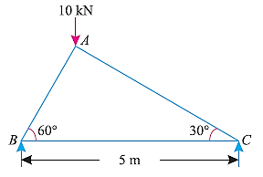 | Apply | 3 | 8M
 |  | (b) | A string ABCD, attached to fixed points A and D has two equal weights of 1000 N attached to it at B and C. The weights rest with the portions AB and CD inclined at angles as shown in Fig. Find the tensions in the portions AB, BC and CD of the string, if the inclination of the portion BC with the vertical is 120°.  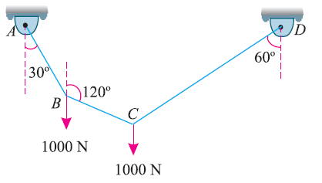 | Apply | 2 | 6M
6 |  | (a) | Find the Centroid of a 100 mm × 150 mm × 20 mm T-section.  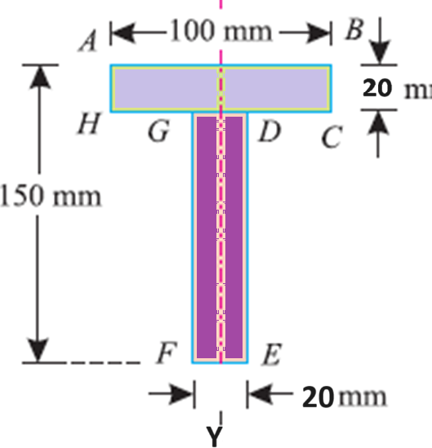 | Apply | 4 | 8M
 |  | (b) | The equation of motion of a particle moving in a straight line is given by: s = 18t + 3t² – 2t³ where (s) is in metres and (t) in seconds. Find (i) velocity and acceleration at start, (ii) time, when the particle reaches its maximum velocity, and (iii) maximum velocity of the particle. | Apply | 5 | 6M
OR
7 |  | (a) | Find the moment of inertia of a T-section with flange as 150 mm × 50 mm and web as 150 mm × 50 mm about X-X and Y-Y axes through the centre of gravity of the section.  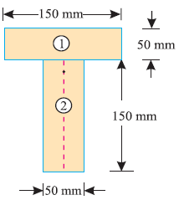 | Apply | 4 | 8M
 |  | (b) | A body is moving with a velocity of 2 m/s. After 4 seconds the velocity of the body becomes 5 m/s. Find the acceleration of the body. How much distance it has travelled after 4 seconds. | Apply | 5 | 6M
8 |  | (a) | Determine the constant force P that will give the system of bodies shown in fig. Velocity of 3 m/s after moving 4.5m from rest. Coefficient of friction between the blocks and the plane is 0.3. pulleys are smooth.  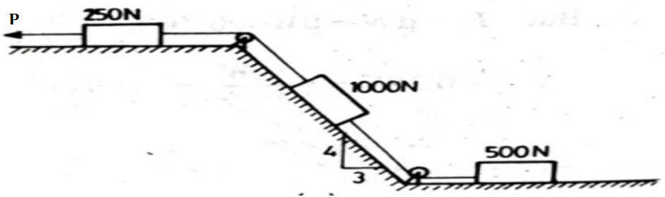 | Apply | 6 | 8M
 |  | (b) | Distinguish between rectilinear motion and curvilinear motion with practical examples. | Understand | 5 | 6M
OR
9 | (a) |  | A block weighing 2500 N rests on a level horizontal plane for which coefficient of friction is 0.2. This block is pulled by a force of 1000 N acting at an angle of 30º to the horizontal. Find the velocity of the block after it moves 30 m starting from rest.  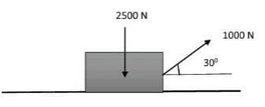 | Apply | 6 | 8M
9 | (b) |  | A ball is thrown vertically upward with an initial velocity of 25 m/s.  - How high will the ball go?  - How long will it take to reach its maximum height? | Apply | 5 | 6M
***********

