

SEMESTER END SUPPLEMENTARY EXAMINATIONS (AR16), JUNE - 2026
U.G. | Common to All |  | Degree | Bachelor of Technology
Academic Year | 2025-2026 |  | Sem. | 2nd
Course Code | 16MEX01 | Course Title
Course Code | 16MEX01 | Engineering Mechanics
Duration | 3 Hours | Maximum Marks |  |  | 60 (SIXTY)
SECTION-I
6 x 2 = 12 Marks
1.
No. | Questions (a to f) | RBT Level | COs
a | Define force and state its characteristics. | Understand | 1
b | State Lami’s theorem. | Remember | 1
c | What is polar moment of inertia? State its importance in engineering applications. | Understand | 3
d | State the Transfer Theorem for Mass Moments of Inertia | Remember | 3
e | Define the terms i) Friction ii) Angle of friction. | Remember | 4
f | List out the assumptions made in the analysis of perfect frame. | Remember | 6
SECTION-II
4 x 12 = 48 Marks
No. |  | Questions (2 to 9) |  | RBT Level | COs | Marks
2 |  | (a) | A system of four forces acting on a body as shown in figure. Determine the magnitude and direction of the resultant.  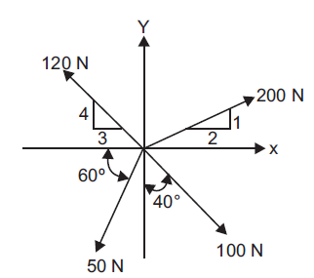 | Apply | 1 | 7M
 |  | (b) | A semicircular area is removed from the trapezoid shown in figure. Determine the coordinates of the centroid for the shaded area.  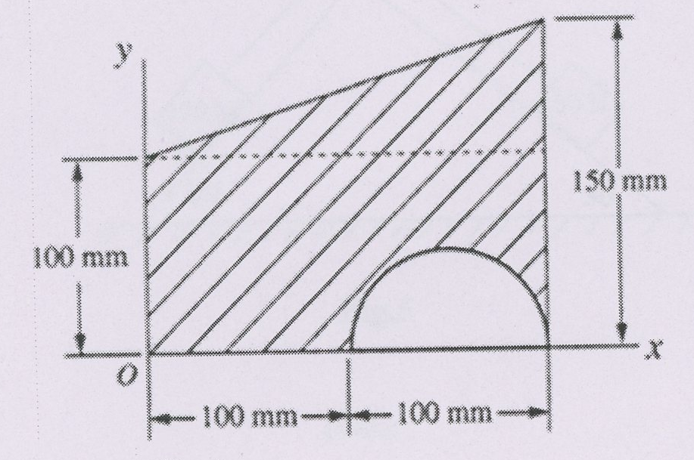 | Apply | 2 | 5M
OR
3 |  | (a) | Two identical rollers, each of weight Q = 1000 N are supported by an inclined plane and a vertical wall as shown in figure. Assuming smooth surfaces, find the reactions induced at the points of support A, B and C.  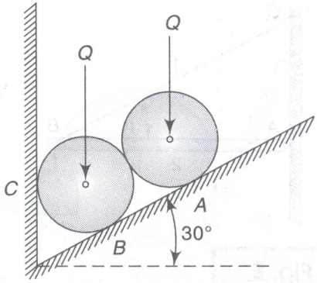 | Apply | 1 | 7M
 |  | (b) | Locate the centre of gravity of the right circular cone of base radius ‘R’ and height ‘h’. | Understand | 2 | 5M
4 |  | (a) | Find the moment of inertia of solid sphere of radius ‘R’ and mass ‘M’ about its diametral axis. | Understand | 3 | 7M
 |  | (b) | Find the centroid of the ‘Z’ section shown in figure.  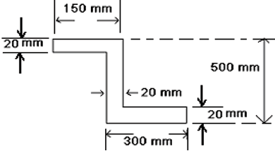 | Apply | 2 | 5M
OR
5 |  | (a) | Find area moment of inertia of ‘L’ section shown in figure about its horizontal centroidal axis.  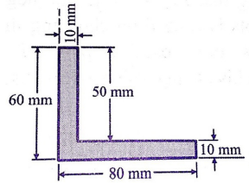 | Apply | 3 | 7M
 |  | (b) | Determine the centroid of a semicircular area of radius ‘R’ about its diametral axis. | Understand | 2 | 5M
6 |  | (a) | Two beams AB and CD are supported on rollers at E and C as shown in figure. The beam AB is hinged at A and beam CD is hinged at D. Determine the reactions at the rollers using the method of virtual work.  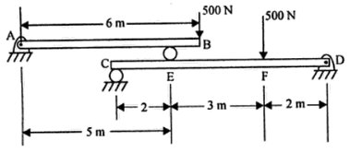 | Apply | 4 | 7M
 |  | (b) | A belt is running over a pulley of diameter 1.5 m at 350 r.p.m. The angle of contact is 150ᵒ and the coefficient of friction is 0.30. If the maximum tension in the belt is 500 N, determine the power transmitted by it. | Apply | 5 | 5M
OR
7 |  | (a) | Block A weighing 1000 N rests over block B which weighs 2000 N. Block A is tied to a wall with a horizontal string. If the coefficient of friction between A and B is 0.25 and that between B and the floor is 0.33, what value of force P is required to create impending motion if P is horizontal.  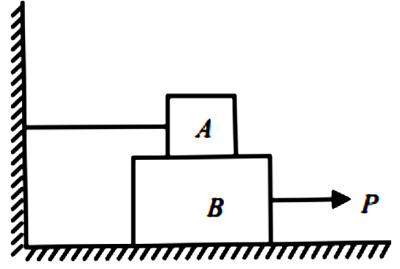 | Apply | 4 | 7M
 |  | (b) | Derive the condition for transmitting the maximum power in a flat belt drive. | Understand | 5 | 5M
8 |  | (a) | Find the forces in all the members of the truss shown in the figure.  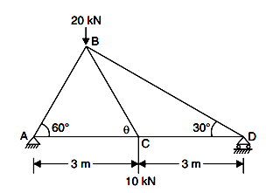 | Apply | 6 | 7M
 |  | (b) | Derive the expression for the ratio of driving tensions for a flat belt drive. | Understand | 5 | 5M
OR
9 | (a) |  | A cantilever truss is loaded as shown in the figure. Find the forces in the members 1 and 2 using method of sections.  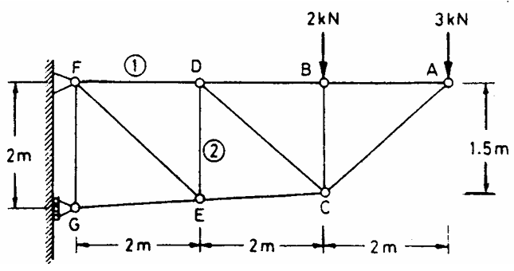 | Apply | 6 | 7M
9 | (b) |  | Discuss about the various types of belt drives with neat sketches. | Understand | 5 | 5M

***********

