

SEMESTER END SUPPLEMENTARY EXAMINATIONS (AR21), MARCH – 2026

U.G. | Common to All |  | Degree | Bachelor of Technology
Academic Year | 2025-26 |  | Sem. | I
Course Code | 21BEX01 | Course Title
Course Code | 21BEX01 | Basics of Engineering
Duration | 3 Hours | Maximum Marks |  |  | 70 (SEVENTY)
SECTION-I
7 x 2 = 14 Marks
1.
No. | Questions (a to g) | RBT Level | COs
a | What is the difference between substructure and superstructure? | Understand | 1
b | Define safe bearing capacity. | Understand | 1
c | List out the components of a steam power plant | Understand | 3
d | Name the main components of a domestic refrigerator. | Understand | 3
e | State Ohm’s Law. | Remember | 4
f | State Faraday’s Laws of Electromagnetic Induction. | Remember | 4
g | List out the applications of Ultrasonic sensors. | Remember | 6
SECTION-II
4 x 14 = 56 Marks

No. |  | Questions (2 to 9) |  |  | RBT Level | COs | Marks
2 |  | (a) |  | Explain the principles of surveying and describe the methods used for measurement of distances and areas. | Understand | 1 | 8M
 |  | (b) |  | Explain different types of roofs used in buildings. | Understand | 2 | 6M
OR
3 |  | (a) |  | Discuss the properties and uses of the following building materials:  - Bricks  - Cement  - Steel  - Concrete | Understand | 1 | 8M
 |  | (b) |  | Describe the different types of foundations used in building construction with neat sketches. | Understand | 2 | 6M
4 |  | (a) |  | Classify power plants and explain the working principles of hydro-electric power plant with neat diagrams. | Analysis | 3 | 8M
 |  | (b) |  | Distinguish between petrol engine and diesel engine | Analysis | 2 | 6M
OR
5 |  | (a) | Explain the simple vapour absorption refrigeration system with a neat schematic diagram. |  | Analysis | 3 | 8M
 |  | (b) | Explain the layout and working of a window type air conditioning system. |  | Analysis | 2 | 6M
6 |  | (a) | Find the current through 12 ohm resistor using mesh analysis in the circuit shown below:  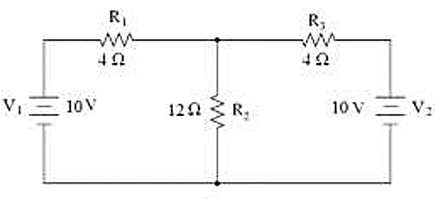 |  | Application | 4 | 8M
 |  | (b) | Explain the operating principle of a D.C Generator. |  | Understand | 5 | 6M
OR
7 |  | (a) |  | Determine the Form factor of a sinusoidal waveform. | Application | 4 | 8M
 |  | (b) |  | Explain the constructional details of a D.C Machine. | Understand | 5 | 6M
8 |  | (a) |  | Explain the working principle of washing machine with a neat block diagram. | Understand | 6 | 8M
 |  | (b) |  | Discuss personal safety measures to prevent electric shock. | Remember | 5 | 6M
OR
9 | (a) |  |  | Discuss about different types of sensors and list out their applications, | Understand | 6 | 8M
9 | (b) |  |  | Write a short note on Indian electrical safety rules. | Remember | 5 | 6M

***********

