

SEMESTER END SUPPLEMENTARY EXAMINATIONS (AR16), MAR – 2026

U.G. | Common to All |  | Degree | Bachelor of Technology
Academic Year | 2025-2026 |  | Sem. | 1st
Course Code | 16MEX01 | Course Title
Course Code | 16MEX01 | ENGINEERING MECHANICS
Duration | 3 Hours | Maximum Marks |  |  | 60 (SIXTY)
SECTION-I
6 x 2 = 12 Marks
1.
No. | Questions (a to g) | RBT Level | COs
a | What are the equilibrium conditions for a rigid body? | Remember | 1
b | What is a free body diagram? | Remember | 1
c | What is meant by centroid? Give examples. | Remember | 3
d | What is parallel axes theorem for moment of inertia? | Remember | 3
e | What is slip of a belt drive? | Remember | 4
f | What are the different types of supports used in frames? | Remember | 6
SECTION-II
4 x 12 = 48 Marks

No. |  | Questions (2 to 9) |  |  | RBT Level | COs | Marks
2 |  | (a) |  | An electric light fixture weighting 15N hangs from a point C, by two strings AC and BC. The string AC is inclined at 60° to the horizontal and BC at 45° to the horizontal as shown in figure. Using Lami’s theorem, or otherwise, determine the forces in the strings AC and BC.  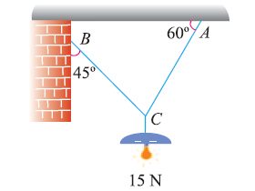 | Apply | 1 | 7M
 |  | (b) |  | Discuss various force systems with neat sketches. | Understand | 2 | 5M
OR
3 |  | (a) |  | Three cylinders weighting 100 N each and of 80 mm diameter are placed in a channel of 180 mm width as shown in figure. Compute the pressure exerted by the cylinder A on B at the point of contact.  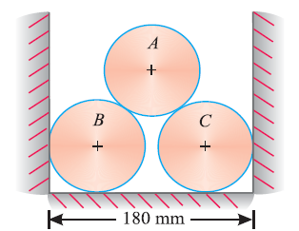 | Apply | 1 | 7M
 |  | (b) |  | State and prove Lami’s theorem. | Understand | 2 | 5M
4 |  | (a) |  | Find the centre of gravity of a 100mm X 150mm X 30mm T section. | Apply | 3 | 7M
 |  | (b) |  | Derive an expression for centroid of a circle. | Understand | 2 | 5M
OR
5 |  | (a) | Find the moment of inertia of a T section with flange as 150mm X 50mm and web as 150mm X 50mm about X-X and Y-Y axes through the centre of gravity of the section |  | Apply | 3 | 7M
 |  | (b) | What is polar moment of inertia? Find the polar moment of inertia of a circle of diameter 50mm. |  | Understand | 2 | 5M
6 |  |  | Two blocks A and B of weights 1 kN and 2 kN respectively are in equilibrium position as shown in figure.  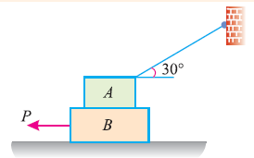.  If the coefficient of friction between the two blocks as well as the block B and the floor is 0.3, compute the force P required to move the block B. |  | Apply | 4 | 12M
OR
7 |  | (a) |  | A leather belt 9 mm × 250 mm is used to drive a cast iron pulley 900 mm in diameter at 336 r.p.m. If the active arc on the smaller pulley is 120° and the stress in tight side is 2 MPa, find the power capacity of the belt. The density of leather may be taken as 980 kg/m³, and the coefficient of friction of leather on cast iron is 0.35. | Apply | 4 | 7M
 |  | (b) |  | Discuss the different types of belts and their material used for power transmission. |  | 5 | 5M
8 |  |  |  | Determine the forces in the members of the frame shown in figure using method of joints.  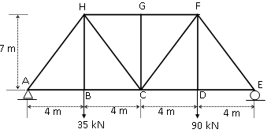 | Apply | 6 | 12M
OR
9 |  |  |  | Determine the axial force in each member of the truss shown in figure below. Use method of joints.  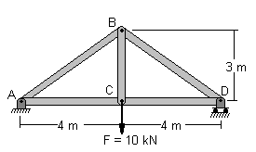 | Apply | 6 | 12M

***********

