

SEMESTER END REGULAR EXAMINATIONS (AR23), MAY – 2026
U.G. | CE |  | Degree | Bachelor of Technology
Academic Year | 2025-2026 |  | Sem. | 6th
Course Code | 23CEH12 | Course Title
Course Code | 23CEH12 | Advanced Structural Analysis
Duration | 3 Hours | Maximum Marks |  |  | 70 (SEVENTY)
SECTION-I
7 x 2 = 14 Marks
1. No. | Questions (a to g) | RBT Level | COs
a | Define the term RLD. | Remember | 1
b | Define the term ILD. | Remember | 1
c | State Upper bound theorem. | Remember | 3
d | Define the term Plastic section modulus. | Remember | 3
e | Define the term flexibility. | Remember | 4
f | Define the term stiffness. | Remember | 4
g | Write down the relationship between flexibility and stiffness. | Remember | 6

SECTION-II
4 x 14 = 56 Marks
No. |  | Questions (2 to 9) |  |  | RBT Level | COs | Marks
2 |  | (a) |  | A simply supported beam of span 6 m carries a moving point load of 30 kN. Using influence line diagram, determine the maximum bending moment at a section located 2 m from the left support. | Apply | 1 | 8M
 |  | (b) |  | Determine the shape factor for a triangular section. | Apply | 2 | 6M
OR
3 |  | (a) |  | A simply supported beam of span 12 m carries a uniformly distributed load of 5 kN/m over the entire span. Using influence line diagram, determine the maximum bending moment at a section located 4 m from the left support. | Apply | 1 | 8M
 |  | (b) |  | Determine the shape factor for a circular section. | Apply | 2 | 6M
4 |  | (a) |  | Find out the plastic moment capacity of a fixed beam subjected to point load at its mid span. | Apply | 3 | 8M
 |  | (b) |  | Determine the shape factor for a rectangular section. | Apply | 2 | 6M
OR
5 |  | (a) | Find out the plastic moment capacity of a simply supported beam subjected to uniformly distributed load w kN/m whole over the span. |  | Apply | 3 | 8M
 |  | (b) | Determine the shape factor for a T section having 120 mm X 10 mm web and 10 X 120 mm Flange dimension. |  | Apply | 2 | 6M
6 |  | (a) | Find out the deflection at point B and C due to the applied external load for the given figure1.  FigureF  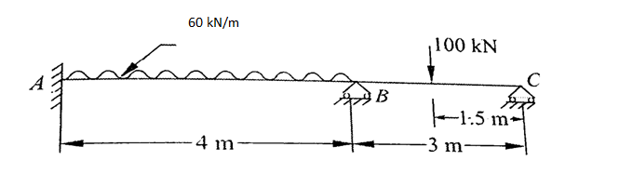Figure.1. |  | Apply | 4 | 8M
 |  | (b) | Develop the stiffness matrix equation for Figure1. |  | Apply | 5 | 6M
OR
7 |  | (a) |  | Find out the flexibility coefficient for the given Figure1. | Apply | 4 | 8M
 |  | (b) |  | Find out the final end moment and draw the end moment diagram for Figure1. | Apply | 5 | 6M
8 |  | (a) |  | A continuous beam ABC with spans 5 m each carries no external load. The middle support B undergoes a settlement of 8 mm downward. Using the flexibility method, develop the flexibility matrix. | Apply | 6 | 8M
 |  | (b) |  | Find out the final end moment and draw the end moment diagram for Question No. 8(a). | Apply | 5 | 6M
OR
9 | (a) |  |  | Develop the stiffness matrix equation for Figure1. if support B sinks 5 mm. | Apply | 6 | 8M
9 | (b) |  |  | Differentiate flexibility and stiffness matrix methods. | Understand | 5 | 6M
***********

