

SEMESTER END SUPPLEMENTARY EXAMINATIONS (AR16), MAY - 2026
U.G. | Civil Engineering |  | Degree | Bachelor of Technology
Academic Year | 2025-26 |  | Sem. | 6th
Course Code | 16CE601 | Course Title
Course Code | 16CE601 | Structural Analysis II
Duration | 3 Hours | Maximum Marks |  |  | 60 (SIXTY)

SECTION-I
6 x 2 = 12 Marks
No.1 | Questions (a to f) | RBT Level | COs
a | What is rib shortening? | Remember | CO1
b | Write any two zero-bending moment cases in arches. | Understand | CO2
c | List any two methods of approximate methods of analysis. | Remember | CO3
d | What are the reasons to cause sway in frames? | Understand | CO4
e | Define the stiffness factor and write its value when the far end is fixed and hinged. | Remember | CO5
f | Differentiate the displacement method and force method. | Understand | CO6

SECTION-II
4 x 12 = 48 Marks
No. |  | Questions (2 to 9) | RBT Level | COs | Marks
2 |  | A three-hinged circular arch hinged at springing points and crown point has a span of 40m and a central rise of 8m. It carries an udl of 20kN/m over half of the span together with a concentrated load of 100kN at the right quarter span point. Find the reactions at the supports, normal thrust, radial shear, and bending moment at 10m from the left support. | Apply | CO1 | 12M
OR
3 |  | A two-hinged parabolic arch of span 21 m has a rise of 4 m. The arch is loaded with a point load of 8kN at a horizontal distance of 6 m from the left support. Determine the horizontal thrust, reactions, and bending moment under the load. | Apply | CO2 | 12M
4 |  | Analyse the frame shown below by portal method.  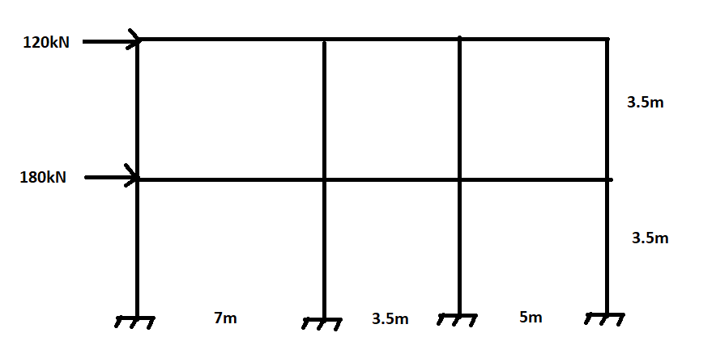 | Apply | CO3 | 12M
OR
5 |  | Analyse the continuous beam shown in the figure by slope deflection method and draw the BMD.  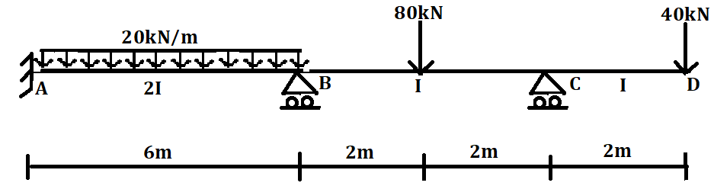 | Apply | CO4 | 12M
6 |  | A beam ABC 16 m long fixed at A and C and continuous over support B carries an udl of 3 kN/m over the span AB and a point load of 10 kN at the mid-span of BC. Span AB = 8m and BC = 8 m. Take EI is constant throughout. Analyse the beam using the moment distribution method. Draw SFD & BMD. | Apply | CO5 | 12M
OR
7 |  | In a continuous beam shown in Fig. The support ‘B’ sinks by 10mm. Determine the moments by Kani’s method and draw BMD. Take E = 2x10⁵ N/mm² & I = 1.2x10⁻⁴ mm⁴  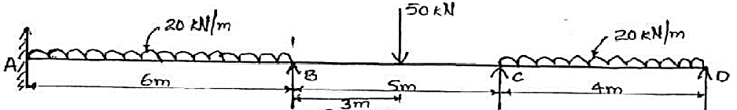 | Apply | CO5 | 12M
8 |  | A two-span continuous beam ABC is fixed at A and simply supported over the supports B and C. AB = 10 m and BC = 8 m. moment of inertia is constant throughout. A single central concentrated load of 10 kN acts on AB and a uniformly distributed load of 8 kN/m acts over BC. Analyse the beam by stiffness matrix method. | Apply | CO6 | 12M
OR
9 | Analyse the continuous beam ABC shown in the figure by the flexibility matrix method and sketch the bending moment diagram.  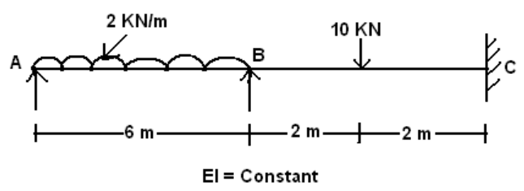 |  | Apply | CO6 | 12M

***********

